5. Create a branch in GitHub and implement all the programs in that branch
and push the code into the same branch. Share the GitHub details to
evaluate. Use GitHub commands to complete this assignment

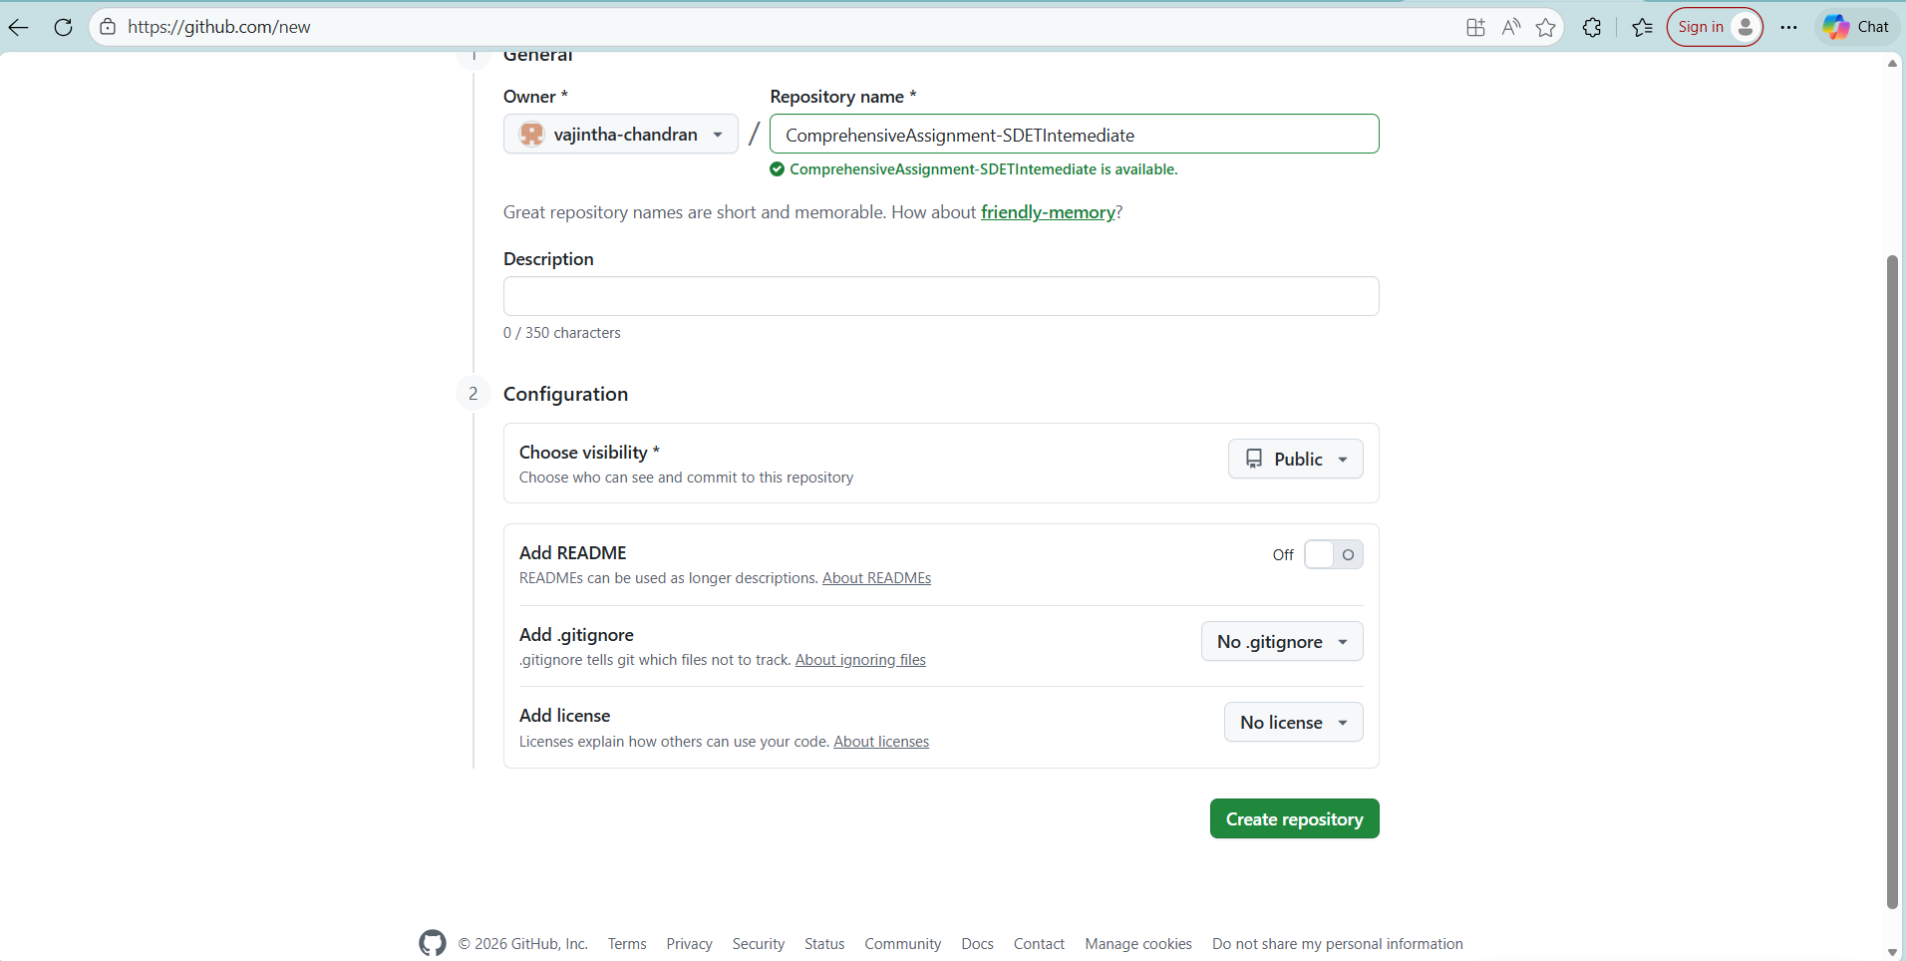
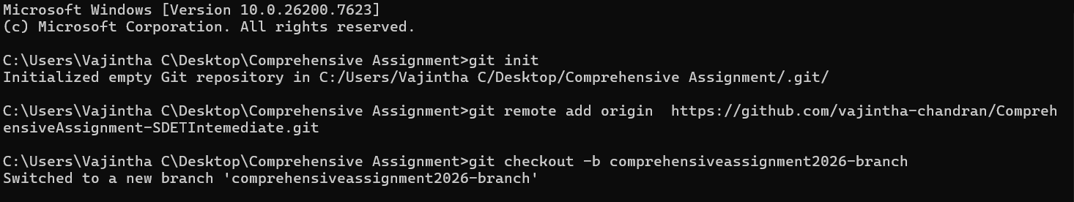

Used command: git add .
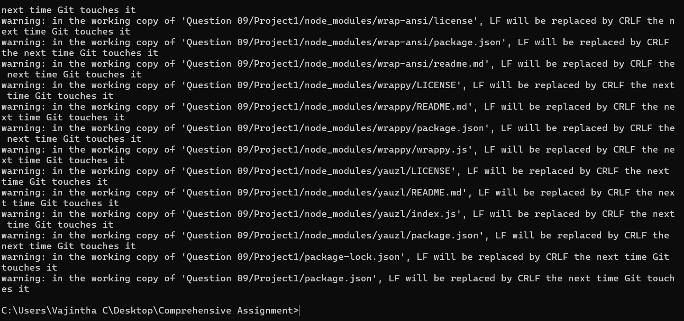
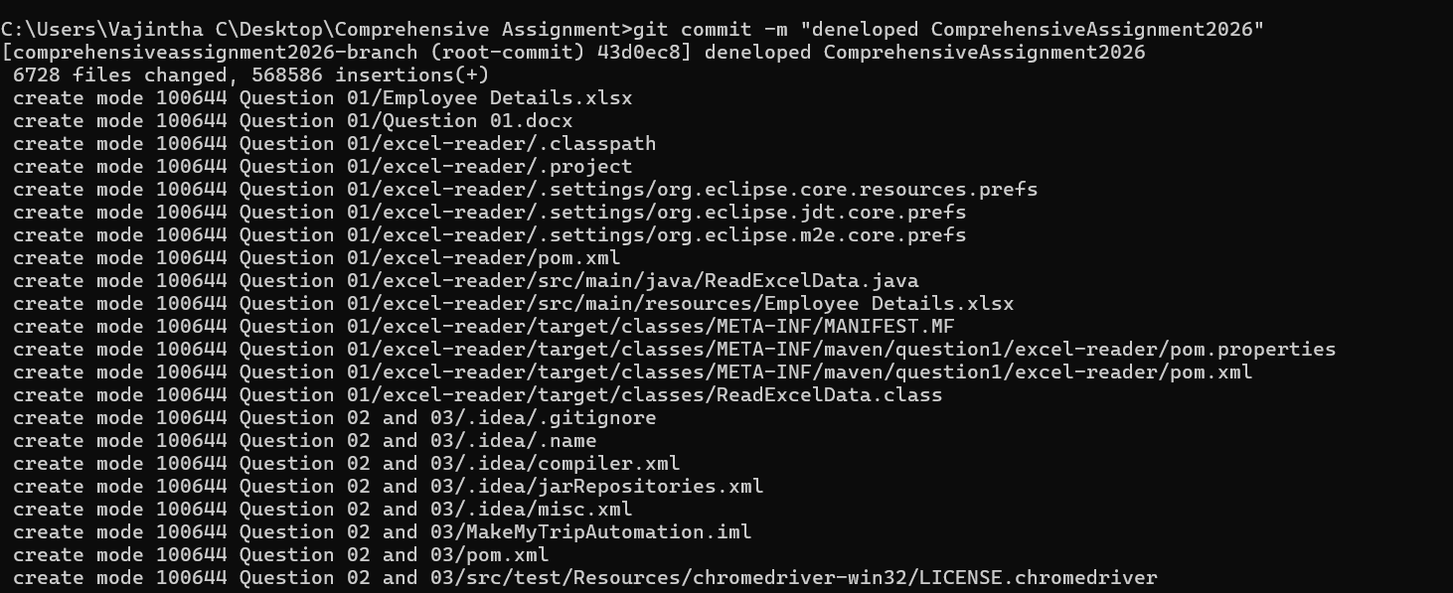

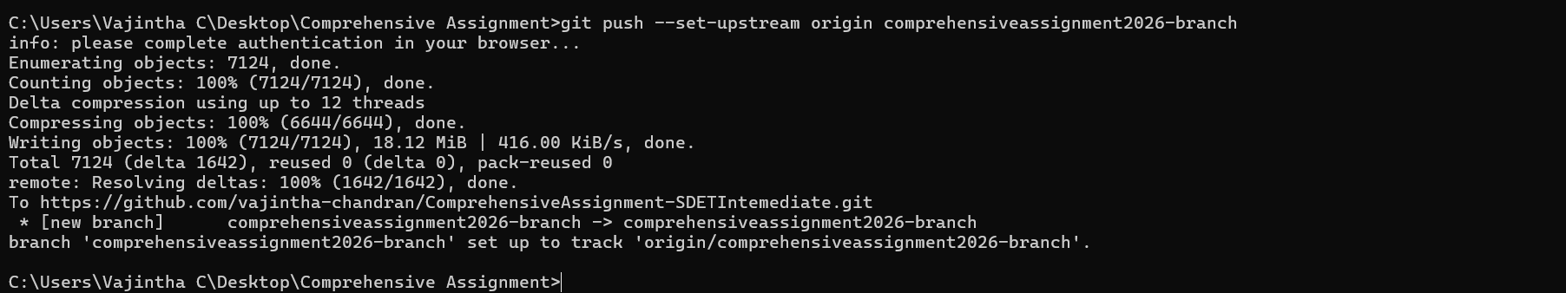
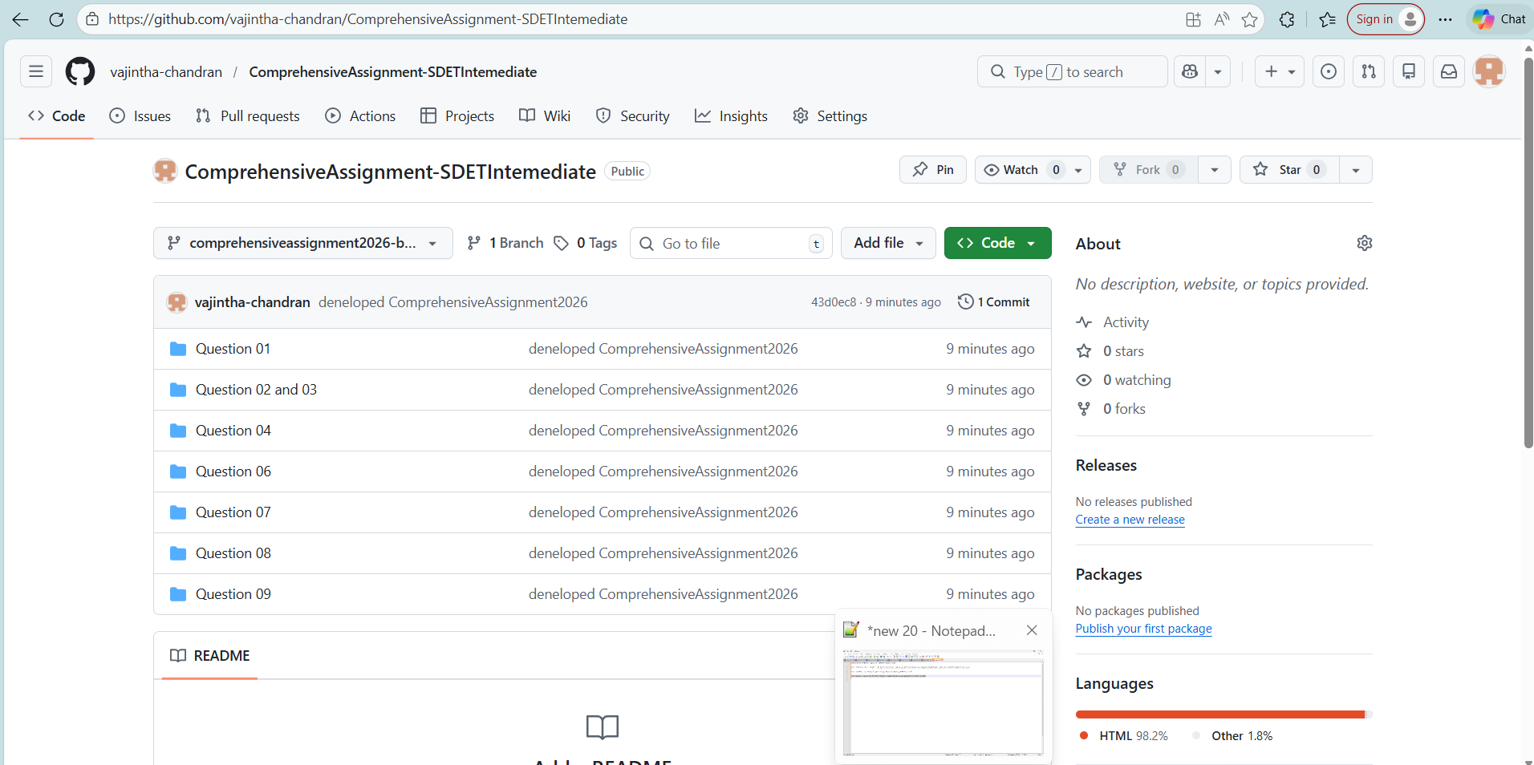

Branch name: comprehensiveassignment2026-branch
https://github.com/vajintha-chandran/ComprehensiveAssignment-SDETIntemediate/tree/comprehensiveassignment2026-branch

